PJF How to Using Audacity


Using Audacity to Record Audio

How to Download Audacity http://audacity.sourceforge.net/download/

GENERAL GUIDELINES:
(SEE MORE CONTROLS & HOW TO'S at the end of this document)
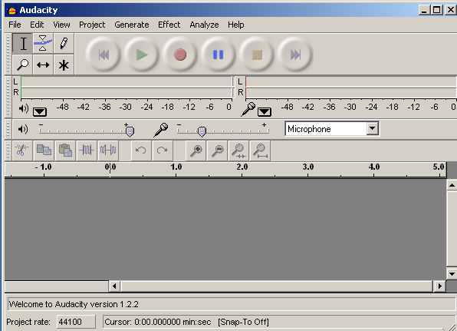

Step 1
Open Audacity
Figure 1
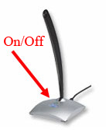

Make sure the microphone is on and plugged into the correct plug on your computer.

Step 2
Select the source for your recording.
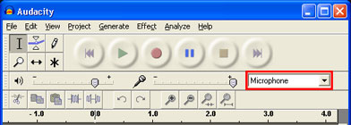

Figure 2

Step 3
Go to File > Preferences > Quality and make sure that the that the sample rate is set to 22050, and the sample format is set to 16bit.
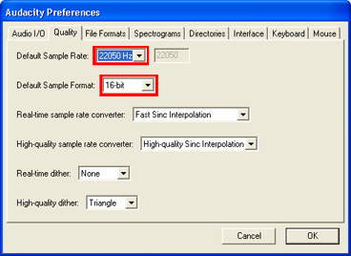
Figure 3

Step 4 Record your voice (You are a disc jockey…..)

Practice a couple of times (watch your levels) and then have a go

"Welcome to Teen radio (pause) (emphasis) Triple C

yes this is (your name) talking to you from the greatest pop station in Perth.

Sit back and relax, jump up and jive or just let it all hang out with rock and rap on you favourite airwaves coming to you on 97.8 FM

Press the Record button in the Audacity program to begin recording. Start speaking….. NOW!

If you would like to pause before continuing, press the Pause button. To continue when you are ready, press the Record button.
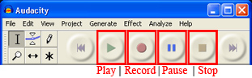

Step 5
As you're recording, you'll see the levels of your voice being recorded. They should look similar to the levels shown.

Hint: If you notice a lot of extreme peaks, stop recording and listen to the audio you've recorded. If you hear a lot of distortion due to the levels being to high or if the levels aren't loud enough adjust your Mic volume.

When you've finished recording, press Stop.

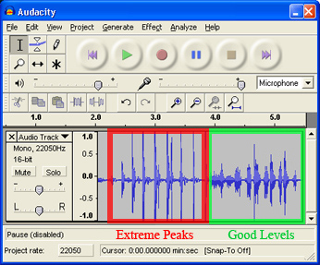 Figure 5

Once you are done recording, push the Stop button to stop recording.

Sound Blast

Step 6 Signature tune (5-10 secs max)

Once you are done recording, push the Stop button to stop recording.
(signature tune – record now)

Now gather together some music weird sounds, make your own and mix voice and music if you wish, Record these on a new file.

You should cut and paste snippets of the type of music that you play make them into one short track then combine the two audio tracks into one with the music following the voiceover.

See add audio below.

Select File > Export As MP3. And as a WAV

A window will pop up explaining that your tracks will be combined. Click OK.

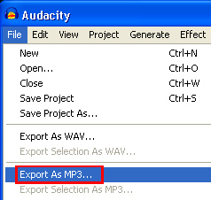

Save to a location on your hard drive. A window will pop up asking you to label the artist/track information of your file. You may leave this blank.

Now open a music sample and add your voice over the top (voice over)

Save this as your initials_voiceover1

Audacity projects contain audio clips arranged onto tracks along with additional information. The project's structure is stored in an AUP file, with audio and housekeeping information in numerous small files in a folder in the same directory as the AUP file. For example, if you have a project named "MyProject" there will be a file called "MyProject.aup" and a folder called "MyProject_data".

- Never rename the .aup file or the _data folder.
If you want to rename your project (for example, to save a snapshot at a particular point), use the File > Save Project As command.
- Always keep the .aup file and the _data folder together in the same directory (folder).
- If you import an audio file with the "Read uncompressed file directly from the original (faster)" option checked in Import / Export Preferences, never move, rename or delete that file, unless you first copy it into the Audacity project. See File > Check Dependencies for more information.
Whilst this Audacity Project Format makes working with the audio more rapid, the format is not compatible with any other audio program. When you Save an Audacity project, you save in the Audacity Project Format, i.e. as an AUP file. The AUP file cannot be used in an MP3 player.

If you have audio which you want to use in Audacity but which wasn't recorded in Audacity, you will usually need to Import the audio. This is also an option on the File Menu.

EDITING TIPS

Tracks are created every time you start and stop recording. The first time you begin recording, the audio will record into a single track. If you stop and then press record again, the program will begin recording audio on the second track, and so on. Note: It is important that the audio portion of each track NOT overlap on the timeline. (Figure 7)

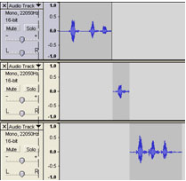

Add Audio
To add audio, click the selection tool (Figure 8), then click the point on the timeline where you would like your recording to begin and click Record. This will create a new track.

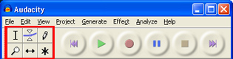

Move Audio
Move the audio on a track to the left or right along the timeline by using the Time Shift Tool (Figure 8)
To extend or contract your selection, hold down the SHIFT button and click on the area you wish your selection to extend or contract to.

If you click at a spot that is on the right hand side from the middle of the current selection, you will set the right hand boundary of your new selection.

Select File > Export As MP3. or as a WAV

your initials_welcome.wav

Delete Audio
In order to delete unwanted sections of audio, highlight the part you want to remove using the mouse and press the Delete key.

Insert Silence
If you want to replace the selection with silence, select Edit > Silence. If you want to create silence for a section of the track, select that section using the mouse and select Generate > Silence. (Note: Unlike Edit > Silence, Generate > Silence does not replace the selected portion, it adds equivalent time in silence.)

Audio and PowerPoint

Open your PowerPoint presentation and go to the slide you want the audio to be on
In PowerPoint select Insert > Movies and Sound > Sound from file... (locate your file and press OK)
Select Yes or No depending on if you want the audio file to play automatically or not.

Main Window
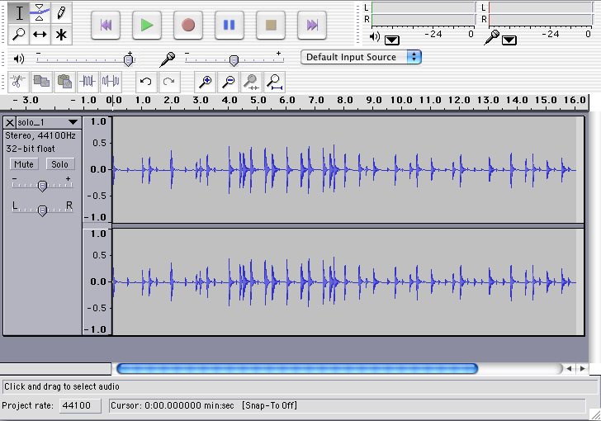
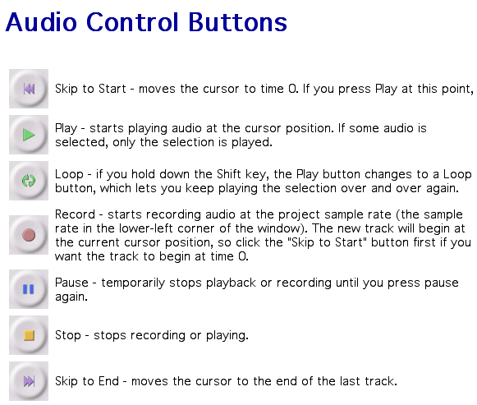

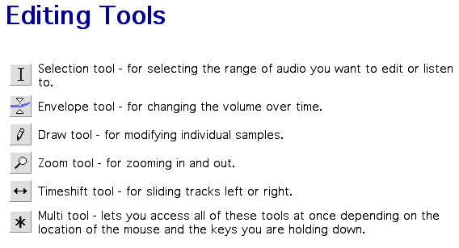
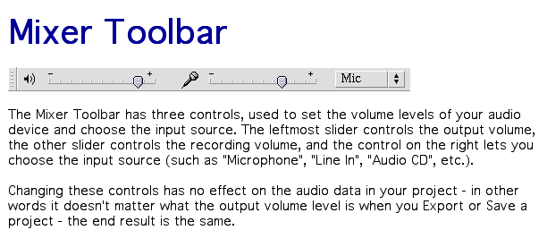
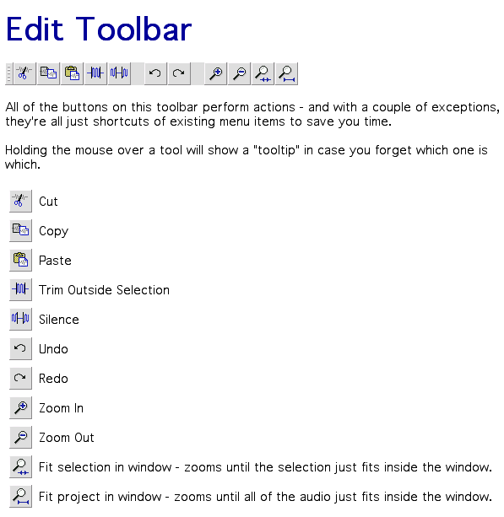

Reference

file:///*%20Audio%20Converters/Audacity%201.3.12/help/manual/index.html

